[Organization Name] is part of AMGA’s national health campaign,
Rise to Immunize® (RIZE)!

RIZE is a four-year initiative focused on empowering organizations like ours to increase routine adult immunization rates. The campaign goal is for participants to collectively administer 25 million vaccines by 2025, with a focus on influenza, pneumococcal, Td/Tdap, and zoster vaccines. We are one of 82 medical groups who have joined this quality improvement initiative.

As a participant of the campaign, all employees at our organization have access to the following vaccine resources, which are available at RiseToImmunize.org. To be added to the campaign listserv and receive the newsletter, webinar registration details, and access to the RIZE Community, email RiseToImmunize@amga.org.
Campaign Planks – evidence-based care processes to drive improvement in vaccination rates. Planks fall under one of five domains: Provider & Staff Education, Clinical Support, IT/Documentation, Patient Education, and Financial Management.
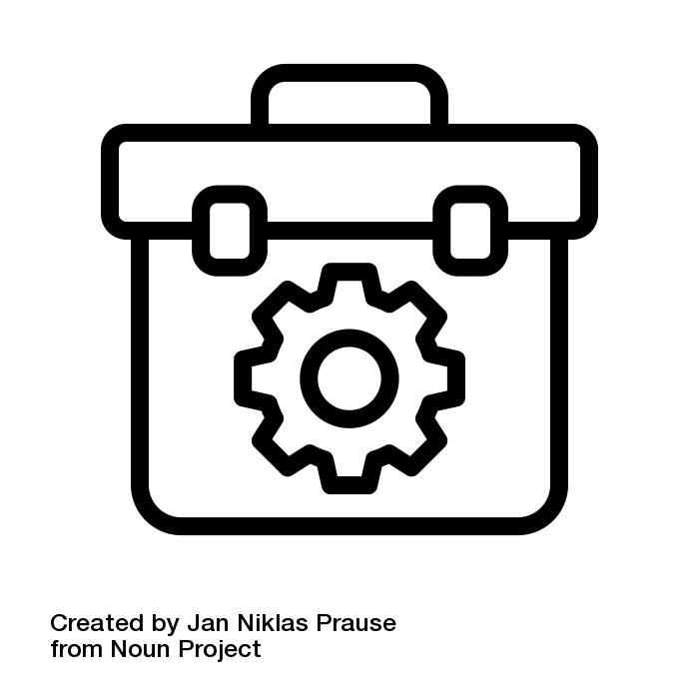
Campaign Toolkit – digital resource offering tools from peer medical groups and health systems to support implementation of the “campaign planks.”
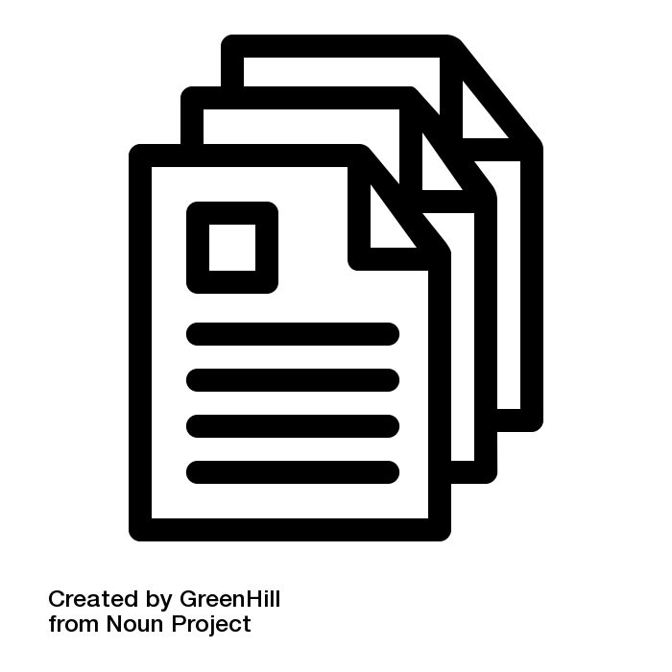
Provider and patient resources – free, timely educational resources from national partners and corporate sponsors.
Campaign webinars – monthly webinars featuring speakers from leading health organizations sharing best practices to improve vaccination rates and tackle complex immunization challenges.
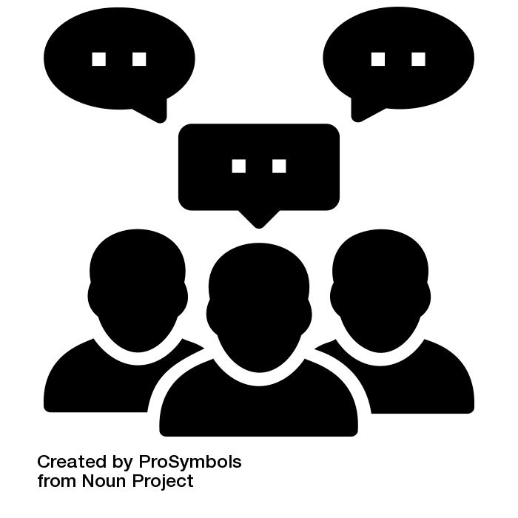
RIZE Community – 24/7 private listserv to connect directly with campaign participants. These conversations allow for peer-to-peer problem solving and the sharing of best practices.
RIZE Casts – on-demand video series sharing tips for improving immunization rates.
Benchmarking reports – quarterly blinded comparative reports measuring progress and assessing group performance on vaccines administered or documented.
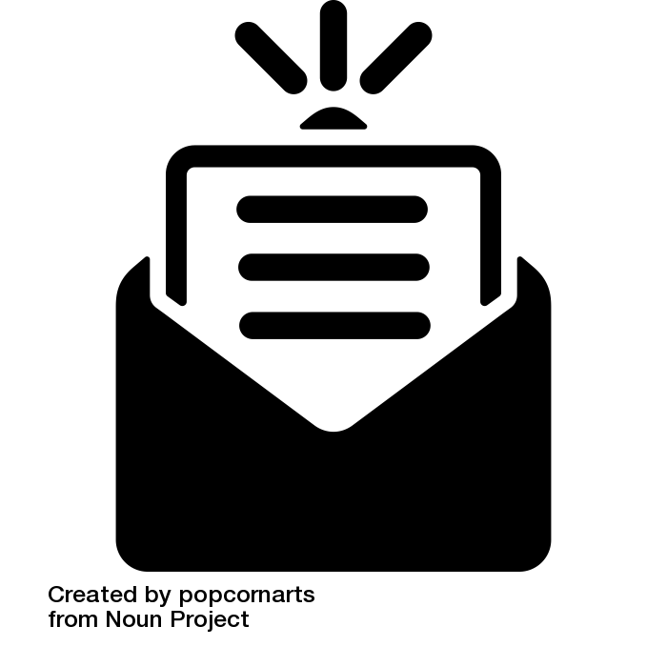
RIZE Monthly – a monthly newsletter to share campaign updates, resources, and opportunities.

