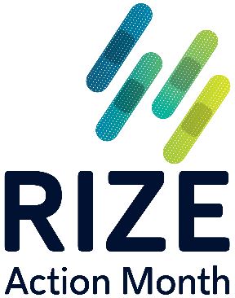
2023 Staff Invitation Template

Please customize the staff invitation template below to communicate the details of your RIZE Action Month meeting to your immunization team. The content can be modified for an email, calendar invitation, posting on your internal portal, or even team newsletter.

Remember, your 30-minute RIZE Action Month meeting can be held virtually or in person. Depending on the channel you use, consider asking for RSVPs from staff so you can get an accurate headcount for food and/or refreshments. If holding a virtual meeting, RSVPs will help ensure that you are able to provide gift cards for team members ahead of the event so that everyone is still able to enjoy a snack or refreshments together. As a reminder, RIZE will reimburse participating AMGA members up to $100 for food and refreshments or gift cards for virtual events.

From: [RIZE Action Month Meeting Leader]
To: [Immunization Team members]

Subject: Discuss respiratory season vaccine strategies over [meal, coffee, snacks, etc.] on [date]!

Hello -

As you may know, [organization name] is one of over 80 medical groups and health systems participating in AMGA’s Rise to Immunize™ (RIZE) campaign. This national campaign aims to improve routine adult immunization rates and collectively administer 25 million vaccines by 2025.

RIZE will hold its annual observance—RIZE Action Month—in August, to coincide with Immunization Awareness Month. During the month, health professionals across the country will “take action” to improve routine adult immunization rates.

On [date], we are “taking action” by conducting a brief vaccination refresher over [breakfast, lunch, snack] and discussing our strategies for the upcoming respiratory season.

Here are the details:

[Date, time]
Who: [Organization]’s immunization team
What: [Organization]’s RIZE Action Month meeting over [breakfast, lunch, snack]
Where: [Location or virtual meeting link]
Why: To collaborate as a team on our strategies for the upcoming respiratory season—particularly to discuss effective influenza and pneumococcal vaccination strategies—and ultimately improve immunization rates within our practice.

We hope you will join us!
[Name of RIZE Action Month meeting Leader]

